**STUDENT PERFORMANCE ANALYSIS**

**INTRODUCTION**

A Student performance analysis is crucial for understanding academic trends, identifying strength and weakness and making data driven decisions to enhance learning outcomes.

In recent years, educators and school administrators have been focused on improving student performance. However, there are key factors influencing student success which are often unclear. This analysis aims to uncover insights into student performance across subjects, attendance trends, and age-related variations. By understanding these patterns, schools can implement targeted strategies to enhance academic outcomes.

**PROBLEM STATEMENT**

Finding out student performance across all subjects

To answer the above question, we will need to answer further questions like

* What is the Students Performance across all subjects?
* Who are the overall best students based on performance?
* Are there Outliers in the datasets?
* What is the Performance rate of Student per Age?
* What is the total attendance of Student per month?
* Who are the students with the highest and lowest attendance?
* What is the performance rate of students per gender?

**ABOUT THE DATA**

The data contains about 200 records taken on a few students, capturing various attributes:

* **Student ID –** Unique identifier for each student.
* **Name**: An identifier that helps distinguish individual records.
* **Age –** Helps analyze performance across different age groups.
* **Gender –** Allows for analysis of performance differences by gender.
* **Math, Science, and English Scores –** Measures student performance in core subjects.
* **Attendance –** The number of days a student was present.
* **Date –** Represents when subjects were taken.
* **Grade Levels –** Classification of students based on performance**.**

**DATA PREPARATION**

This Datasets, comprising of 200 rows and 9 columns was generated using **ChatGPT** to represent student performance data. It was then imported into an Excel spreadsheet as a structured table, organized into rows and columns for analysis.

**DATA CLEANING**

* Handle missing/null values.
* Check for outliers and correlation
* Remove Duplicates
* Ensure data consistency
* Confirmation of the Data type
* Data Validation (Check for accuracy of data)

**DATA ANALYSIS & KEY METRICS**

I use Excel functions, Pivot Tables and Charts to derive insights

* Average Attendance Per Students
* Gender Count
* Average Math Score
* Average Science Score
* Average English Score

**DATA VISUALIZATIONS, KEY FINDINGS AND INSIGHTS**

* **Students Performance trends across all subjects:**

**Who Excelled and Who Struggled?**

Every student has their strengths, and our analysis revealed some clear patterns. **Math Score emerged as the strongest subject overall**, with an average score of **70.6%**, showing that students generally performed well in numerical reasoning. **English and Science Scores followed closely, with average of 66.1% and 66.2%, respectively.**

But looking deeper, individual student performance tells a more refined story. **Eve stood out in Math,** achieving the highest average score of **75%**,while **Frank faced challenges,** scoring the lowest at **66%**.

In **English**, **Alice proved to be the strongest performer, scoring an impressive 77%**, yet she struggled in **Science**, where she recorded the lowest score of **57%**. **Grace, on the other hand, excelled in Science with a high score of 74%,** but **Eve and Bob struggled in English, each scoring just 63%**.

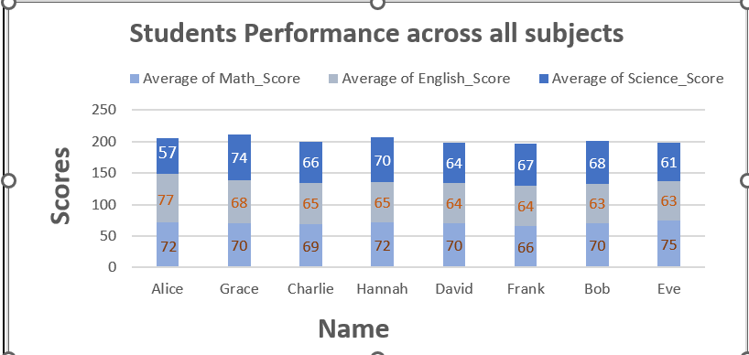

These insights highlight an important takeaway:

1. **No single student dominated across all three subjects.**
2. Each student had different learning strengths, which suggests the need for personalized tutoring programs to help them improve in weaker subjects.
3. Focusing on Science education in particular could help students achieve more balanced academic success.

* **Students with the highest and lowest attendance:**

**Grace had the highest attendance (2,365 days),** while **Frank had the lowest (1,660 days).**

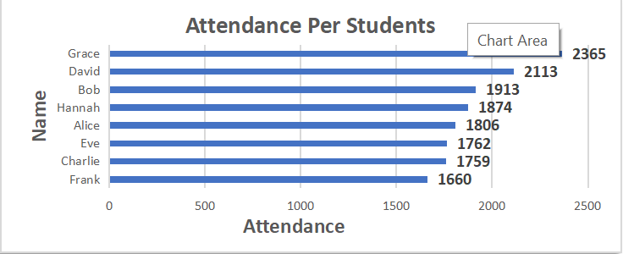

Despite having high attendance, some students did not score exceptionally well, suggesting that **attendance alone does not guarantee high performance.**

Students with attendance above **80% scored an average of 75%, while those below 70% attendance scored around 60%.**

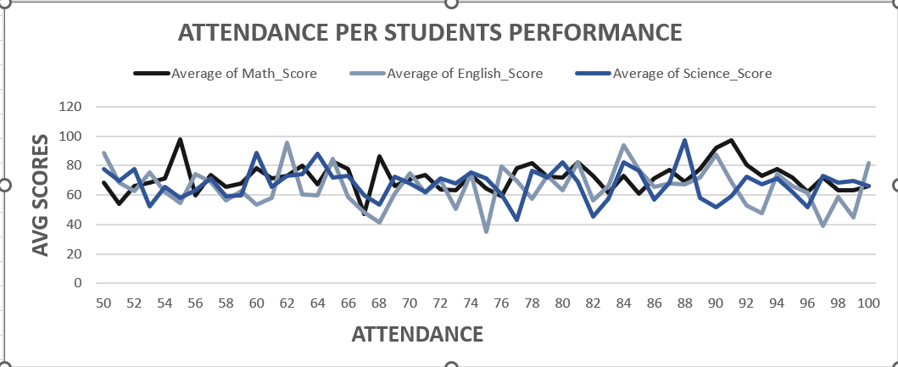

* **Performance rate of students per Age:**

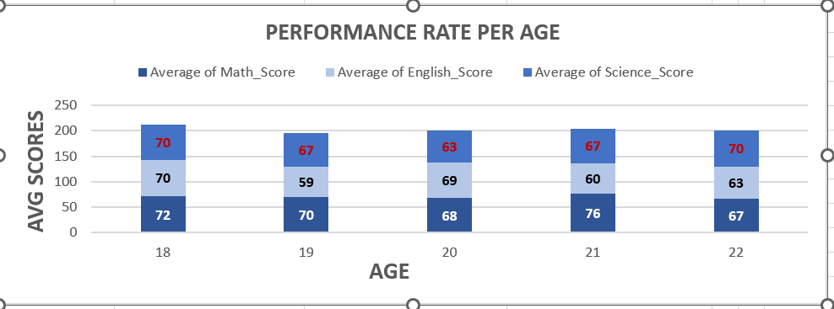

Students aged **18, 21, and 22** performed best across subjects, averaging **70-76%.**

These insights highlight an important takeaway:

1. Older and Younger students showed good performance, with some excelling well in Math, followed by other subjects
2. Furthermore, students of aged **18,21,22** may have developed better study habits, more discipline or received additional tutoring.

* **Performance rate of students per Gender**

At first glance, one might assume that female students are stronger overall due to their higher math and science scores, but the difference is not uniform across all subjects. The data suggests that while gender may play a role in performance trends, other factors such as study habits, interest levels could also contribute.

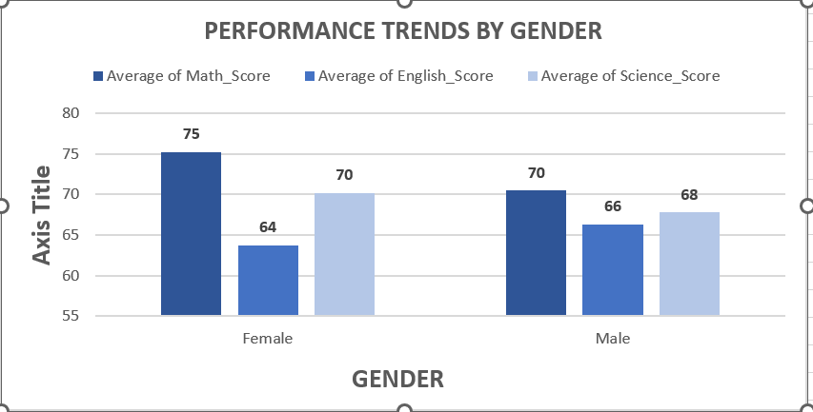

Female students demonstrated a strong command of **Math**, achieving an average score of **75%**, while their male scored slightly lower at **70%**.

However, when it came to **English**, males outperformed females, with an average score of **66%** compared to **64%** for females.

In **Science**, the performance gap was small, with females scoring 70% and males 68%.

These insights highlight an important takeaway:

1. This highlights the importance of gender-inclusive teaching strategies to ensure all students regardless of gender receive the support they need to thrive in all subjects.

* **Total Attendance of students across months:**

1. **Highest attendance was in August (1,717),** while Low attendance was in **September (982)**
2. While we couldn’t find a factor to back up our insights, we would advised the school authorities to add more factors for a better analysis and investigate why attendance was high in August and drop in september

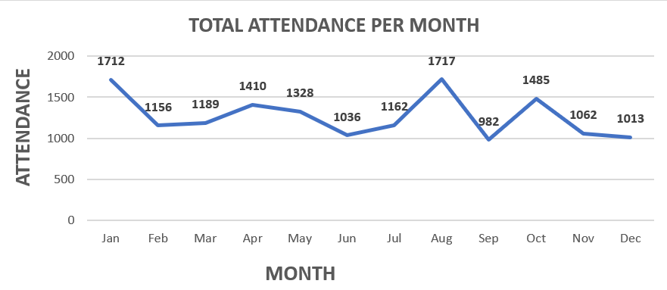

* **Performance based on the overall best students:**

From this datasets, we had eager learners each with their unique strengths and challenges, as the final scores were shown , we saw a clear picture of their performance emerged

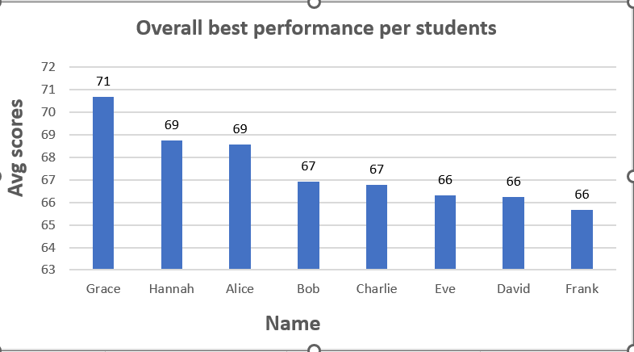

1. At the top of the list stood **Grace** whose hard-work earned her the highest average score of **71**. She consistently performed well setting a benchmark for her peers. **Hannah** and **Alice** followed right behind her scoring **69** proving resilience and competition.
2. Further down the line, **Bob** and **Charlie** shared a scores of **67** showing steady but average performance compared to the top three. Lastly, **Eve, David,** and **Frank** scored **66** demonstrating effort by all means. while their scores are not drastically low, this suggests possible challenges in certain subjects. Identifying those weak areas can help them improve.
3. In the end, the numbers reveal not just a well competitive performance but opportunities for growth, learning and pursuit of excellence.

These insights highlight an important takeaway:

1. The score ranges from **66 to 71** suggests that while there are differences in performance, no student is drastically behind. This means the class has a relatively balanced level of achievement.
2. Since no one scored exceptionally low, with the right methods like personalized tutoring, study plans, and engagement strategies, every student in this dataset has the potential to improve.

**CONCLUSION**

Based on the analysis, we can draw the following conclusion:

* Students performed well overall, but had subject-specific strengths and weaknesses**.**
* **Math scores were generally higher compared to Science and English**
* **Attendance alone does not have an impact on performance.**
* **There were fluctuations in attendance across months, with August showing peak attendance and September showing really low attendance with no factors to get a deeper insight.**

**RECOMMENDATION**

Here are a few recommendations:

* **Introduce Tutoring Programs** – Provide extra support for students struggling in specific subjects.
* **Encourage Improvement in Specific Subject** –Focus on Science education for a better improvement
* **Expand the Dataset for Future Analysis** – Include factors like extracurricular activities, home environment, parental involvement, study habits to refine future insights
* **Add more years for better patterns and analysis**– The dataset is static and does not show how student performance has changed over different years.
* **Gender-inclusive teaching strategies**–Ensure all Students receive support they need, have access to equal learning resources regardless of the gender to improve performance.
* **Improve Attendance Policies** – Address and investigate the rise in August attendance and the drop in September attendance.